**MINISTRY OF EDUCATION AND SCIENCE OF**

**KYRGYZ REPUBLIC**

**INTERNATIONAL ALATOO UNIVERSITY**

**FACULTY OF NEW TECHNOLOGIES**

**DEPARTMENT OF COMPUTER SCIENCE**



**DIPLOMA PAPER**

**Developing Document Exchange Software for AIU.**

**By Nuraly Kaparov**

**Thesis Advisor: Nurlan Shaidullaev**

**Bishkek – 2018**

**КЫРГЫЗ РЕСПУБЛИКАСЫНЫН БИЛИМ БЕРYY ЖАНА ИЛИМ МИНИСТИРЛИГИ**

**ЭЛ АРАЛЫК АЛАТОО УНИВЕРСИТЕТИ**

**ЖАҢЫ ТЕХНОЛОГИЯЛАР ФАКУЛЬТЕТИ**

**ИНФОРМАТИКА ЖАНА ТЕХНИКА**

**ИШТЕП ЧЫГАРУУ БӨЛYМY**



**ДИПЛОМДУК ИШ**

**АЭУ үчүн документ алмаштыруу программасын ишке ашыруу.**

**Аткарган: Нуралы Капаров**

**Жетекчиси: Нурлан Шайдуллаев**

**Бишкек – 2018**

**МИНИСТЕРСТВО ОБРАЗОВАНИЯ И НАУКИ**

**КЫРГЫЗСКОЙ РЕСПУБЛИКИ**

**МЕЖДУНАРОДНЫЙ УНИВЕРСИТЕТ АЛАТОО**

**ФАКУЛЬТЕТ НОВЫХ ТЕХНОЛОГИЙ**

**ОТДЕЛЕНИЕ ИНФОРМАТИКИ И**

**ВЫЧИСЛИТЕЛЬНОЙ ТЕХНИКИ**



**ДИПЛОМНАЯ РАБОТА**

**Разработка Системы документооборота для МУА.**

**Выполнил: Нуралы Капаров**

**Руководитель: Нурлан Шайдуллаев**

**Бишкек – 2018**

**INTERNATIONAL ALATOO UNIVERSITY**

**FACULTY OF NEW TECHNOLOGIES**

**DEPARTMENT OF COMPUTER SCIENCE**

**ABSTRACT**

**Developing Document Exchange Software for AIU.**

**Diploma paper**

**By Nuraly Kaparov**

|  |
| --- |
| Management activities in Alatoo International University, as in all organizations, are carried out with the help of documents, which simultaneously are the source, result and instrument of this activity.  In the paper version of the workflow, we can not track where the document is and at which stage of implementation it is. Transporting documents takes time and the document may be lost on the way, or there may be some error in the document, and it will take time to correct the error.  This software will provide an opportunity to change traditional workflow into electronic format of work. This software will provide system for creating, interpreting, transferring, receiving and archiving documents. |

**Keywords: NodeJS, Mongodb, Express, Angular, Web application**

**Thesis Advisor: Nurlan Shaidullaev Date:**

**ЭЛ АРАЛЫК АЛАТОО УНИВЕРСИТЕТИ**

**ЖАҢЫ ТЕХНОЛОГИЯЛАР ФАКУЛЬТЕТИ**

**ИНФОРМАТИКА ЖАНА ТЕХНИКА**

**ИШТЕП ЧЫГАРУУ БӨЛYМY**

**АННОТАЦИЯ**

**ЭАУ үчүн документ алмаштыруу программасын ишке ашыруу.**

**Дипломдук Иш**

**Капаров Нуралы**

|  |
| --- |
| Алатоо Эл аралык университетинде башкаруу иш-чаралары, бардык эл аралык уюмдардай эле документтердин жардамы менен ишке ашырылат, бир эле убакта булагы, натыйжасы жана иш инструменти болуп саналат.  Жумушту кагаз түрүндө жүргүзгөндө, биз документ жана аны ишке ашыруунун кайсы этапта болгонун байкоо мүмкүн эмес. Документтерди ташуу убакыт талап кылат, ал эми жолдо жоголуп кетип, же документте кандайдыр бир ката бар болушу мүмкүн, ал катаны тууралаш үчүн убакыт талап кылынат.  Бул программа салттуу жумушту электрондук түргө алмаштырууга мүмкүнчүлүк берет. |

**Ачкыч сөздөр: NodeJS, Mongodb, Express, Angular, Веб-кызмат**

**Жетекчиси: Нурлан Шайдуллаев Дата:**

**МЕЖДУНАРОДНЫЙ УНИВЕРСИТЕТ АЛАТОО**

**ФАКУЛЬТЕТ НОВЫХ ТЕХНОЛОГИЙ**

**ОТДЕЛЕНИЕ ИНФОРМАТИКИ И**

**ВЫЧИСЛИТЕЛЬНОЙ ТЕХНИКИ**

**АННОТАЦИЯ**

**Разработка Системы документооборота для МУА.**

**Дипломная Работа**

**Капаров Нуралы**

|  |
| --- |
| Управленческая деятельность в Международном университете Алатоо, как и во всех организациях, осуществляется с помощью документов, которые одновременно являются источником, результатом и инструментом этой деятельности.  В бумажной версии рабочего процесса мы не можем отслеживать, где находится документ, и на каком этапе его реализации. Транспортировка документов требует времени, и документ может быть потерян на пути, или может быть некоторая ошибка в документе, и потребуется время, чтобы исправить ошибку.    Это программное обеспечение предоставит возможность изменить традиционный рабочий процесс в электронный формат работы. Это программное обеспечение будет предоставлять систему для создания, интерпретации, передачи, получения и архивирования документов. |

**Ключевые слова: NodeJS, Mongodb, Express, Angular, Веб-приложение**

**Руководитель: Нурлан Шайдуллаев Дата:**

**Table of Contents**

Cover page.............................................................................................................. i

Abstract .................................................................................................................. ii

List of Tables............................................................................................................ iii

List of Figures.......................................................................................................... iv

List of Abbreviations............................................................................................... v

Table of contents………………………………………………………………………………………………… vi

Introduction ............................................................................................................ 1

I. Chapter....................................................................................................................

II. Chapter....................................................................................................................

.....................................................................................................................................

.....................................................................................................................................

.....................................................................................................................................

Conclusion…................................................................................................................

Bibliography................................................................................................................

Appendix......................................................................................................................

**INTRODUCTION**

Today the document is the main way of presenting information in any modern enterprise. In the modern organization the electronic document management system, become an indispensable element of the IT infrastructure. With their help, commercial companies and industrial enterprises increase their efficiency, and in the state institutions on the basis of electronic document management technologies the tasks of internal management, interdepartmental interaction and interaction with the population are solved.

The importance of safety and skillful use of information resources of the enterprise for successful business is undeniable. The ability to make the right decision and respond in time to the situation, flexibly react to all market changes depends not only on the talent and on experience of managers. The effectiveness of enterprise management depends on how well it is organized in the management of document management.

In International Alatoo University, as in all organizations, are working with the help of documents. In traditional version of workflow, we cannot track where the document is, in which state of implementation it is, or it may be lost.

In my opinion, one of important factors of success is document exchange software (DES). And what I offer is to develop DES, which will solve the above problems.

**CHAPTER 1**

**OVERVIEW OF THE DOCUMENT EXCHANGE SOFTWARE**

Document exchange software, or in other words, a document management system (DMS), is a system which are used for monitoring, management and the storage of documents and reduce the volume of paper. Most of them are capable of recording different versions, created and modified by different users (tracking the story). This term is superimposed on the concept of content management systems. This is often considered a component of business content management (ECM), is associated with the management of digital assets, documents, document management, and records management systems.

Since the 1980s, several suppliers have begun to develop software systems for the management of paper documents. These systems refers to paper, which includes not only printed and published documents, but also photos, prints, and so on.

Later, developers have begun to write the next type of system that could handle electronic documents, that is, all these documents created on computers and are often stored in the user's local file system. Early electronic document management (EDM) controlled or proprietary file types, or a limited number of file formats. Many of these systems were later known as document imaging systems, as they focused on the capture, storage, indexing and retrieval of image file formats. EDM systems have evolved to such a degree that the system can handle any type of file format that can be stored on the network. Applications include steel, electronic documents, collaboration tools, security, workflow and audit capabilities.

These systems allow organizations to capture faxes and forms, save copies of documents as images and store the image files in the repository for security and quick search (extract has been possible thanks to the fact that the system processes the text extracted from the document in the capture process, and the function of the text indexer provided text search capabilities).

While many EDMs store documents in systems of a proprietary file format (Microsoft Word or Excel, PDF), some web document management systems begin to store the content in the form of html. These policy control system requires that content be imported into the system. However, the software after importing the content (for example, Corona Document Management System) acts as a search engine, so users can quickly find what they are looking for. HTML format makes it easier to use the search functions, such as full text search and creation.

* 1. **What is a document and what are its functions?**

The word "document" in Latin means "evidence", "method of proof". A document is a material object with information fixed in it for transferring it in time and space. The document acts simultaneously as both an object of labor of a managerial employee, and as its result.

The most important function of the document is information. In the document facts, events, phenomena of practical and intellectual activity of the person are fixed.

The document has an organizational function. With the help of the document, people's collectives are influenced to organize and coordinate their activities. External communications of enterprises and organizations provide a communicative function of documents.

The document has a legal function, since its content is used as evidence in the consideration of disputes by the parties to the relationship, not to mention the investigative bodies, the court and the prosecutor's office. A number of documents are initially endowed with a legal function (contractual documentation, notarized documents, legal acts of government bodies, etc.).

Finally, the document performs an educational function. He disciplines the performer, requires an increased level of educational training, and a well-designed document fosters the aesthetic taste of management personnel, increases the prestige of the organization.

* 1. **Electronic document**

Electronic document - any text, sound, graphic and other unstructured information created with the help of computer-aided information processing and stored on the computer medium. An electronic document in an electronic document management system consists of a text (the contents of an electronic document) and a form card containing a set of attributes describing the document (document title, author, creation date, correspondent, etc.)

An electronic document contains information that can be used, for example, to find a document or assign it to a particular group. This can be text or an electronic form of Microsoft Word, an Excel spreadsheet or an e-mail message in the Internet, etc. Document files may not contain structural elements (plain text documents) inside themselves, or, conversely, be structured. The latter contain structure elements that allow external applications to receive information about individual information elements (Word forms, spreadsheets, documents in XML format).

Compared to its paper analog, the electronic document has a number of indisputable advantages, such as durability, ease of editing and other work with it, as well as the ability to search by keywords and ease of use in automated enterprise management systems.

Currently, there are various formats of electronic documents, the most common of which is the platform-independent ODF standard ISO 26300.

A special type of documents are database records of specialized group work automation systems, such as Microsoft Exchange electronic forms or 1C documents. Such a document, unlike a conventional electronic document, is not represented as a separate file, but is an integral unit of information that has a unique identifier, a means of displaying and modifying. To this group of documents can be attributed reports generated as a result of the work of applied IP. Such documents are dynamically formed from records of various databases. After viewing or printing such a document ceases to exist in the information system as a single object - it "lives" only within the framework of a certain application, therefore, for example, it must be converted to a different type of document for transfer to another subdivision.

An electronic document acquires legal significance due to an electronic digital signature that is similar to a paper signature and is equivalent to it, provided certain conditions are met.

* 1. **Document Management**

Document management, often referred to as Document Management Systems (DMS), is the use of a computer system and software to store, manage and track electronic documents and electronic images of paper based information captured through the use of a document scanner.

Document management is how your organization stores, manages and tracks its electronic documents.

According to ISO 12651-2, a document is "recorded information or object which can be treated as a unit". While this sounds a little complicated, it is quite simply what you have been using to create, distribute and use for years.

Now, we can define document management as the software that controls and organizes documents throughout an organization. It incorporates document and content capture, workflow, document repositories, COLD/ERM, and output systems, and information retrieval systems. Also, the processes used to track, store and control documents.[1]

**1.2 Related work with other developers.**

In the world I didn’t found such free open source projects. I’ve found similar open source projects, like OpenKM Community version and LogicalDoc Community version, but they don’t have some functions, like Electronic document archiving and searching. There are many software with all functions, but they all commercial products.

**1.2.1 OpenKM** is an Enterprise Content Management Software, often referred to as Document Management Systems (DMS).**[2]** It has OpenKM Community Edition, is the open source document management system version.**[3]**

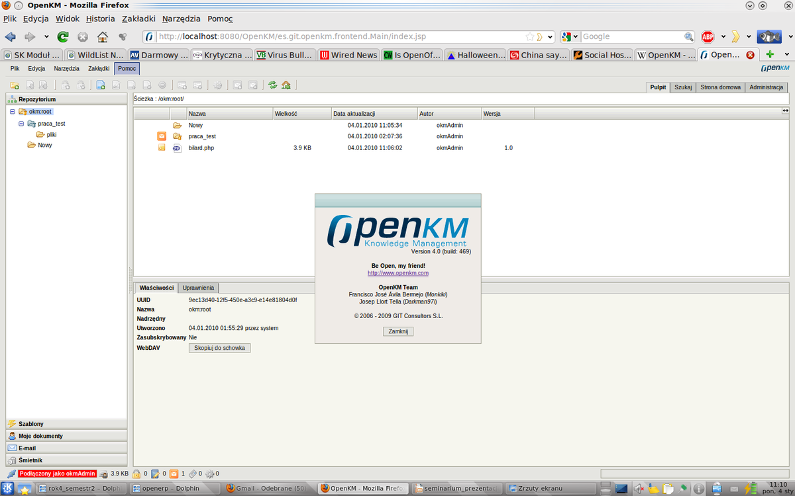

Figure 1 example of OpenKM

OpenKM Community Edition has some disadvantages, such as:

* User limit
* No electronic document archivation
* No electronic document search

**1.2.2 LogicalDOC** is a free document management system that is designed to handle and share documents within an organization. LogicalDOC is a content repository, with Lucene indexing, Activiti workflow, and a set of automatic import procedures. The system was developed using Java technology.[4]

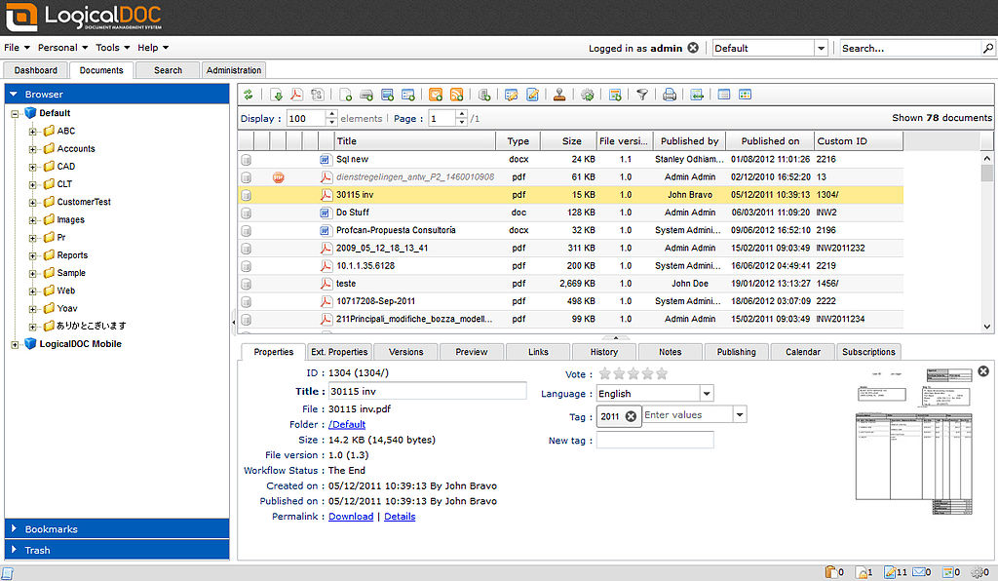

Figure 2 example of LogicalDoc

LogicalDoc Community Edition has some disadvantages, such as:

* No import document from folder
* No archiving

**CHAPTER 2**

**TECHNICAL REVIEW**

In our days it is very difficult to choose the right technology for creating a software.

1. http://www.aiim.org/What-Is-Document-Imaging#
2. https://www.openkm.com/
3. https://www.openkm.com/en/open-source-document-management-system.html
4. https://en.wikipedia.org/wiki/LogicalDOC